Jonny Hughes

Numerical

Homework 5

1. See code
   1. 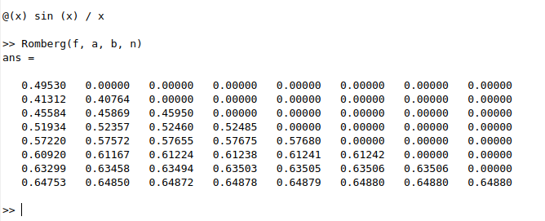
2. 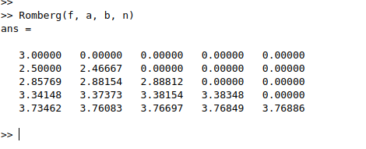
3. 